FACULTY EVALUATION
Programme Name: SBVP ALUMNI MASTERCLASS - GROW Module II Online Kenya (16th March 2026 - 20th March 2026)
Session: Review (identify gaps/challenges) your business plan from module 1 || Decide key issues for long-term sustainability || Identify areas where support is needed
Faculty Name: Dr. William Karani Murithi
No. of Respondents: 11
No. of Participants: 11
Evaluation Parameter | (%) Individual Score | (%) Programme Average
Punctuality (Commencement and Completion of Sessions) | 98 | 98
How well do you understand the core concepts presented? | 93 | 93
Rate your confidence in applying the new skills learnt | 85 | 88
Degree of Faculty preparedness for the sessions | 98 | 98
Content and methodology of the program | 92 | 96
Quality of class and group discussions | 95 | 93
The information presented in the course is relevant to my work (ministry) | 96 | 98
Average scores | 94 | 95

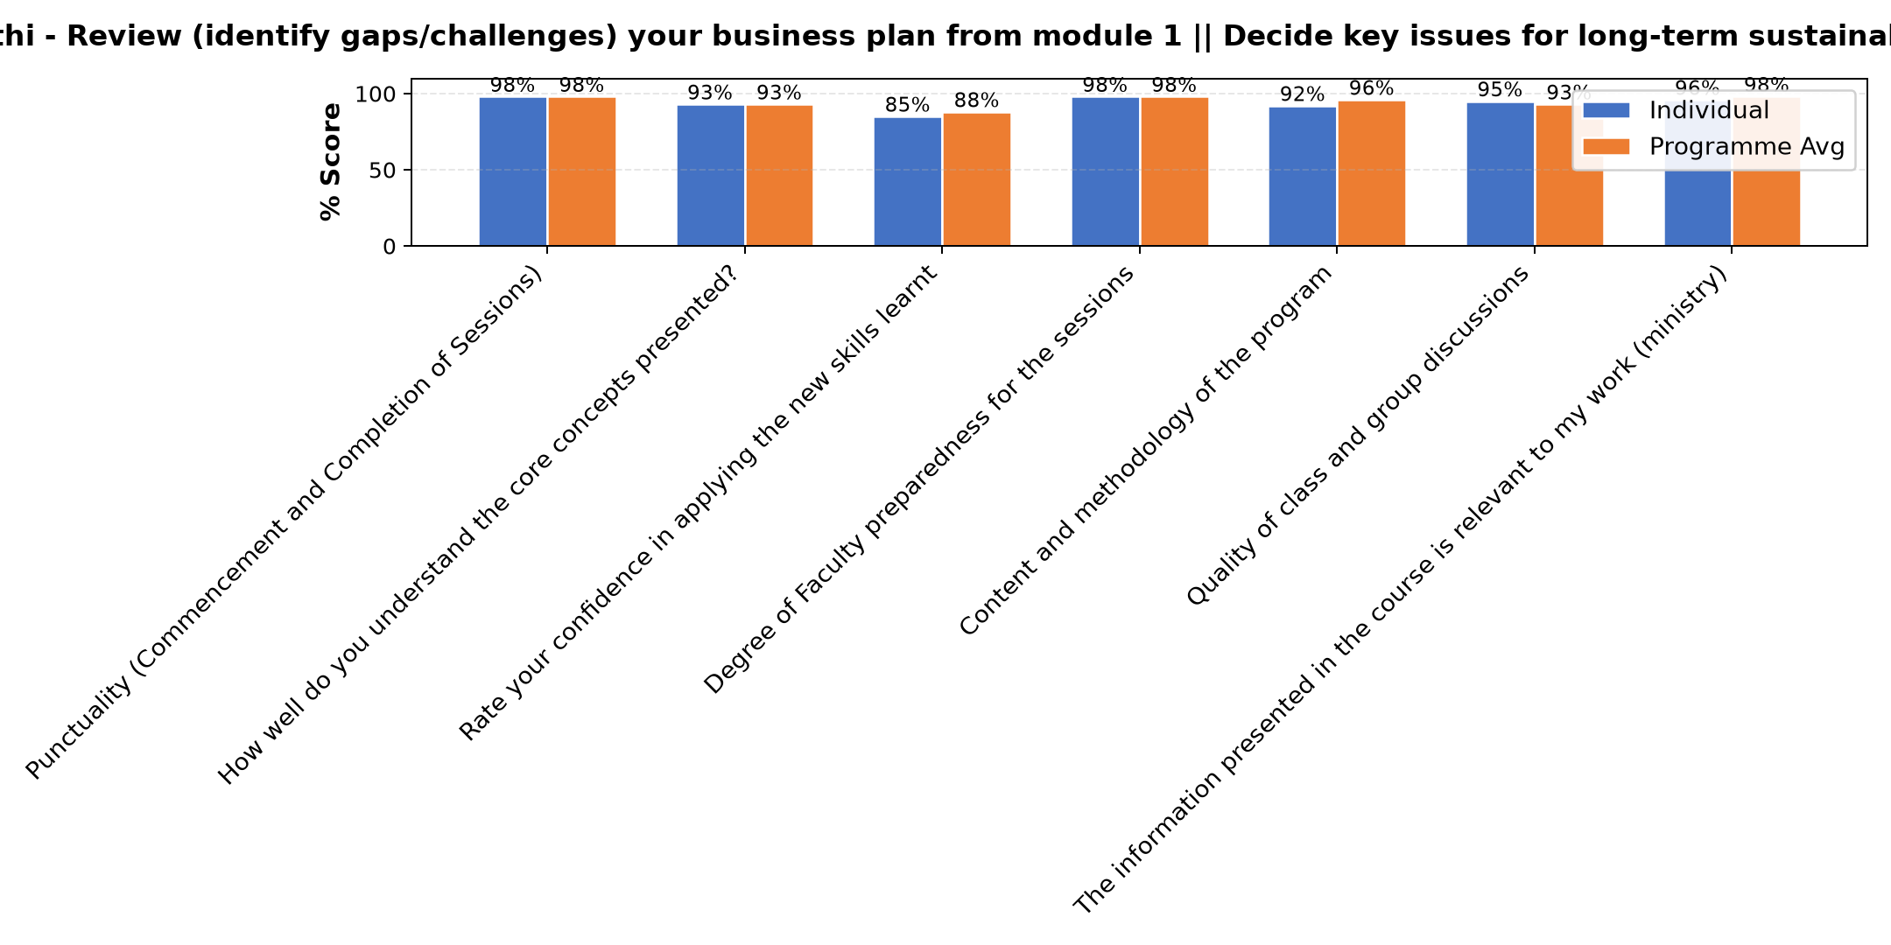

Comments & Feedback
- • Financial thanks to Hilton foundation and Strathmore University
- • Financial constraints
- • Any unplanned changes in the project administration. Otherwise we are committed to applying for he knowledge gained in implementation of the project.
- • Inadequate finances
- • Slowness in engaging the partners and stakeholders in the enterprise
- • The input was very rich
- • Lack of review of our business plan and genuine evaluation of the social enterprise.
- • Lack of enough finance especially during long holidays when we have students out of our hostel facility
SUBMITTED THROUGH:
SBS Evaluation Automation System

